CHAPTER 5: IMPLEMENTATION/DEPLOYMENT

5.1 INTRODUCTION
System implementation is mainly concerned about the installation and delivery of the entire system into use. This chapter focuses on the conversion plan, user manual and user training.

5.2 CONVERSION PLAN
Conversion from one information system (IS) to another is common in all organizations, regardless of type, size or location. This is a technical process by which the new system replaces the old system. There are several approaches to system conversion that could be adopted:
5.2.1. Parallel Conversion
The conversion method to be used is parallel conversion. This method allows both the new and old system to operate fully for a specific period of time. Both systems operate side by side until the project development team and end users agree to switch over to the new system after satisfaction that the new system will be able to run independently without complexities.
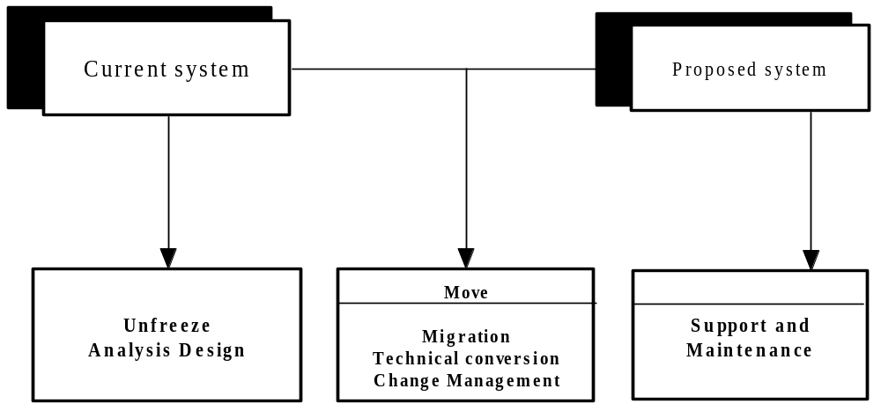

5.2.2. Phased changeover
The system is implemented in stages or modules across the organisation. Phased changeover gives part of the system to the organisation and costs are relatively moderate as the system is implemented in stages rather than at once. Risks of failure are also moderate because the risk associated is limited to the module being implemented.
5.2.3. Pilot Conversion
Both the old and new systems operate at the same time but at a pilot site. The rest of the organisation continues using the old system. This is to say that the system would have to be used by a selected group of users who would further assess its acceptability and functionality.
Advantages
- Moderate costs for there would be the utilization of one site to run both systems
- Moderate risk of failure as the system would have been installed at the pilot site.
- The developed system would have been placed at actual site and tested before actual use.

5.2.4. Direct change over (Recommended strategy)
Direct changeover is the implementation of a new facility, system, process, product or procedure at a point in time. The term implies a major change that is launched all at once as opposed to a more conservative approach such as a phased implementation or parallel run. The old system is immediately replaced by the new system and is abandoned at once. This approach has been chosen because there are no risks associated with moving away from the old system. Furthermore, implementing a fees collection system is not complex. This method would be efficient in that it would minimize duplication of work and it is not costly because only one system will be in operation.

5.3 USER MANUAL
The User Manual contains all essential information for the user to make full use of the information system. The manual includes a description of the system functions and capabilities, contingencies and alternate modes of operation, and step-by-step procedures for system access and use.

System start-up
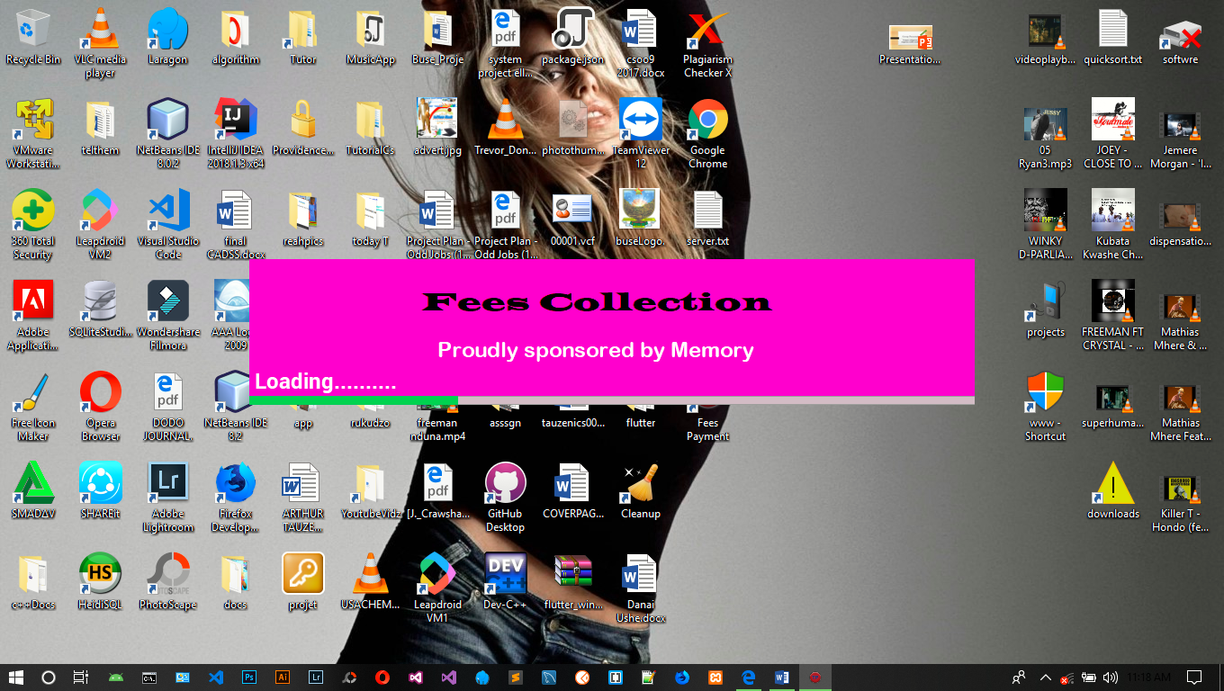

User login

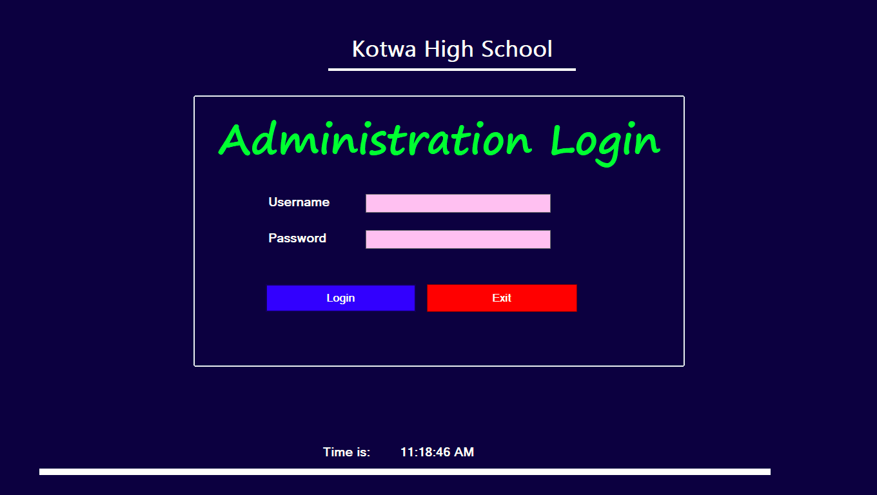

Student registration
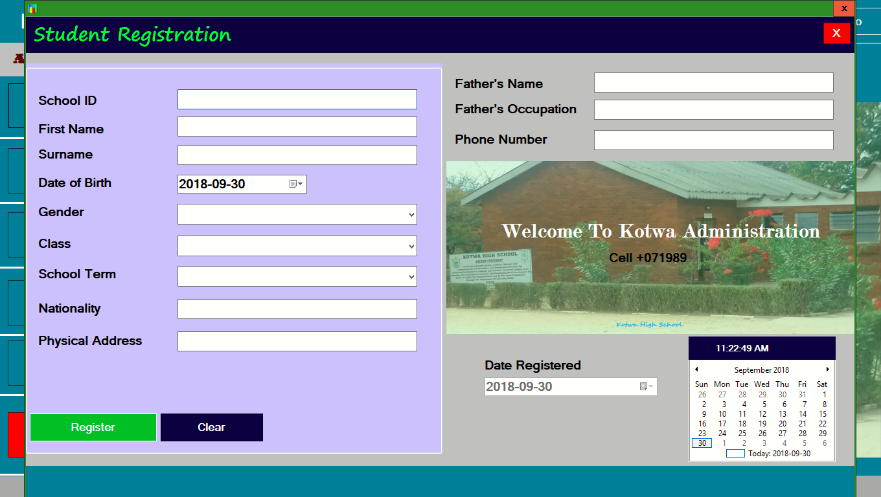

Listing fees payment
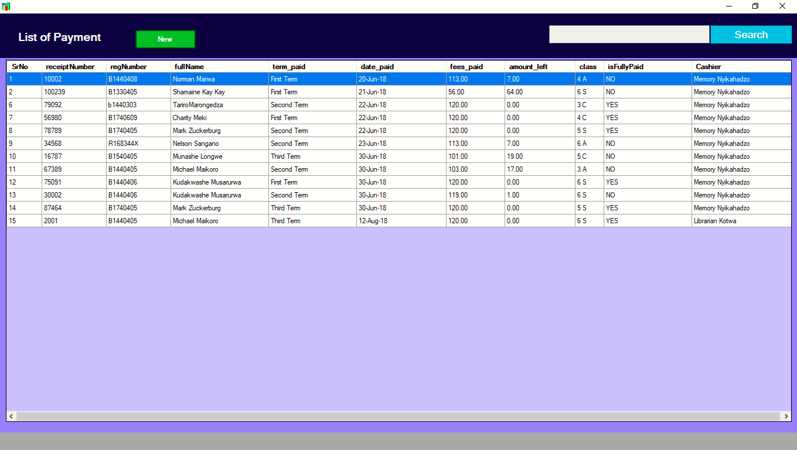
Viewing fees arrears
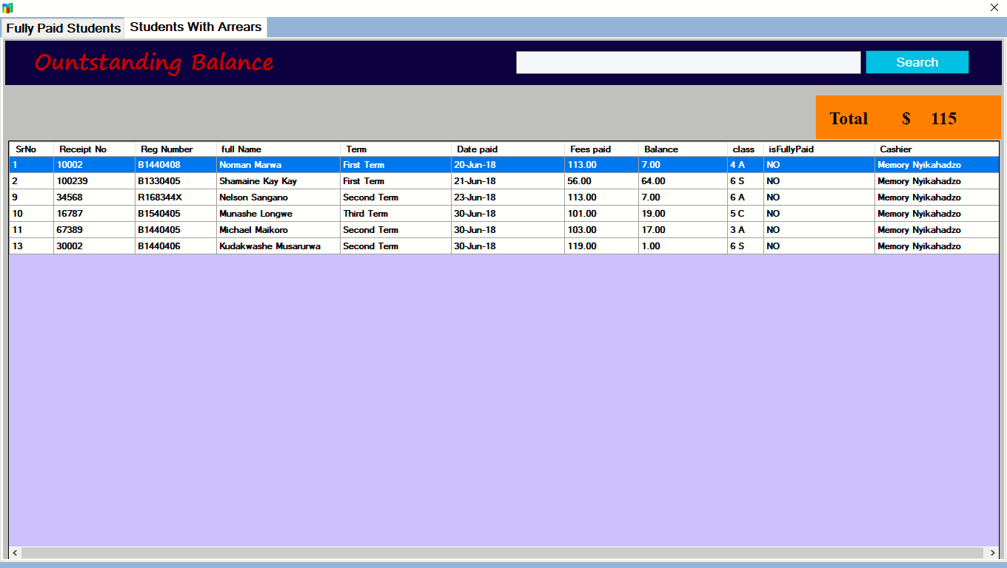

5.4 USER TRAINING
Training is going to facilitate delivery of the right training to the right people at the right time in order for efficient and proper use of the system to be achieved. Training will be provided to the end users before operating the system. The system developer will carry out in-house training to the users. Training will be done on how to easily navigate through the system. The system developer will train all the users on how to access their authorized options and their functions. Below is a list of personnel that the system developer identified for training:
- Cashier
- School Head teacher
- Deputy Head teacher
- Bursar

The following training technique will be followed:
- demonstrations and walk through
- charts

5.4.1. Demonstrations
Demonstrations will enable the systems analyst to demonstrate to the users how to use the system. The systems analyst will demonstrate the procedures for prompting the password, entering data, checking records, and printing of various reports.

5.4.2. Charts
Charts will enable users to follow the procedures in trying to familiarize with the system. The trainer will put data on charts for use to be applied to the real system.

5.4.3. Advantages
- Reduce costly mistakes
- Motivates the workers
- Speeds up processing
- In-house training is cheap

5.5. CONCLUSION
This chapter looked at the actual implementation for the automated school fees collection system for Kotwa high school. The chapter began by outlining the implementation strategies followed by the justification of the chosen strategy. The chapter also, covered the user manual as well as the strtaegies for user training. Next chapter focuses on the evaluation and conclusion.

